## 15.10 Figure S1a- S1b

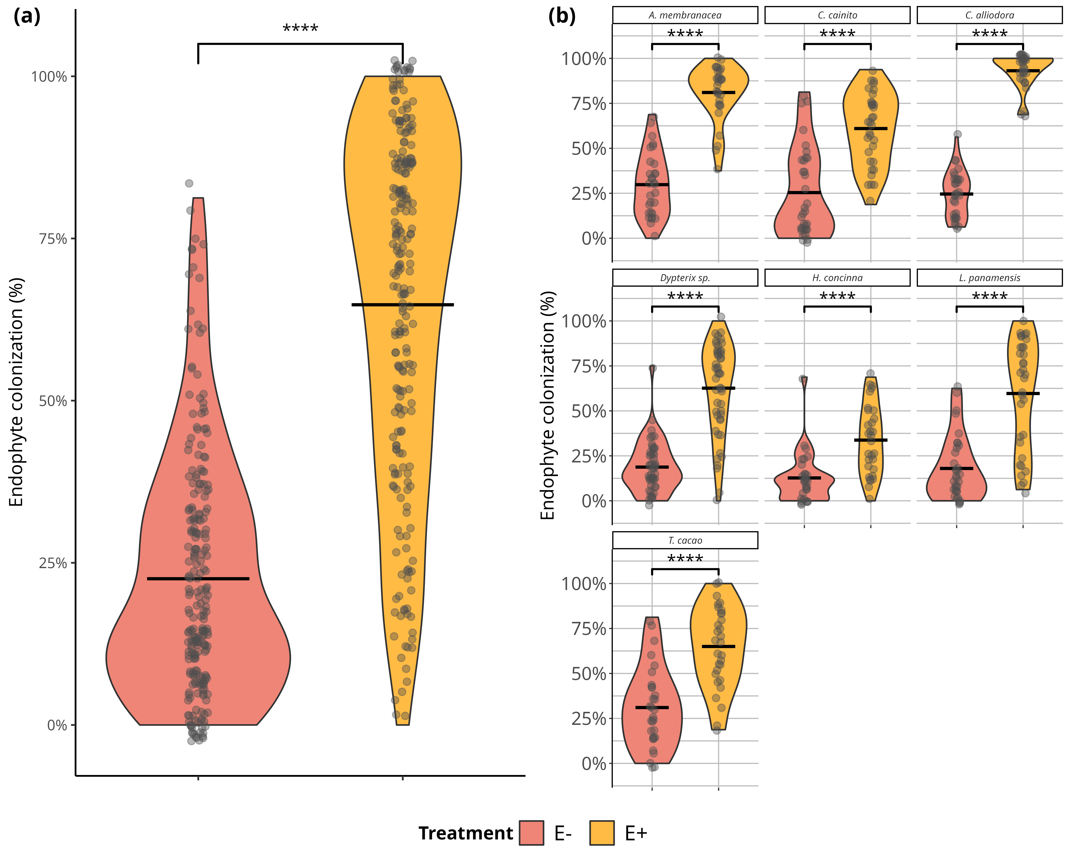

Foliar endophytic fungi (FEF) colonization of seven tropical tree species in malt extract agar (MEA 2%). a) Comparison of mean percent colonization of leaves by FEF measured 7 days after placing leaf pieces on plates. Statistical significance was calculated with a Student’s t-Test. Violin plots show the distribution of colonization values for all tree species within treatment groups (*E-* and *E+*). b) Comparison of mean percent colonization of leaves by FEF measured 7 days after culture. Violin plots show the distribution of percent colonization values for each species per treatment group. Pink filled violins represent low FEF group (*E-*) and yellow filled violins represent high FEF group (*E+*). Significance levels are represented by ns (not significant) and asterisks [p < 0.05 (*), p < 0.01 (**), p < 0.001 (***), and p < 0.0001 (****)]

## 15.11 Figure S2a-S2b

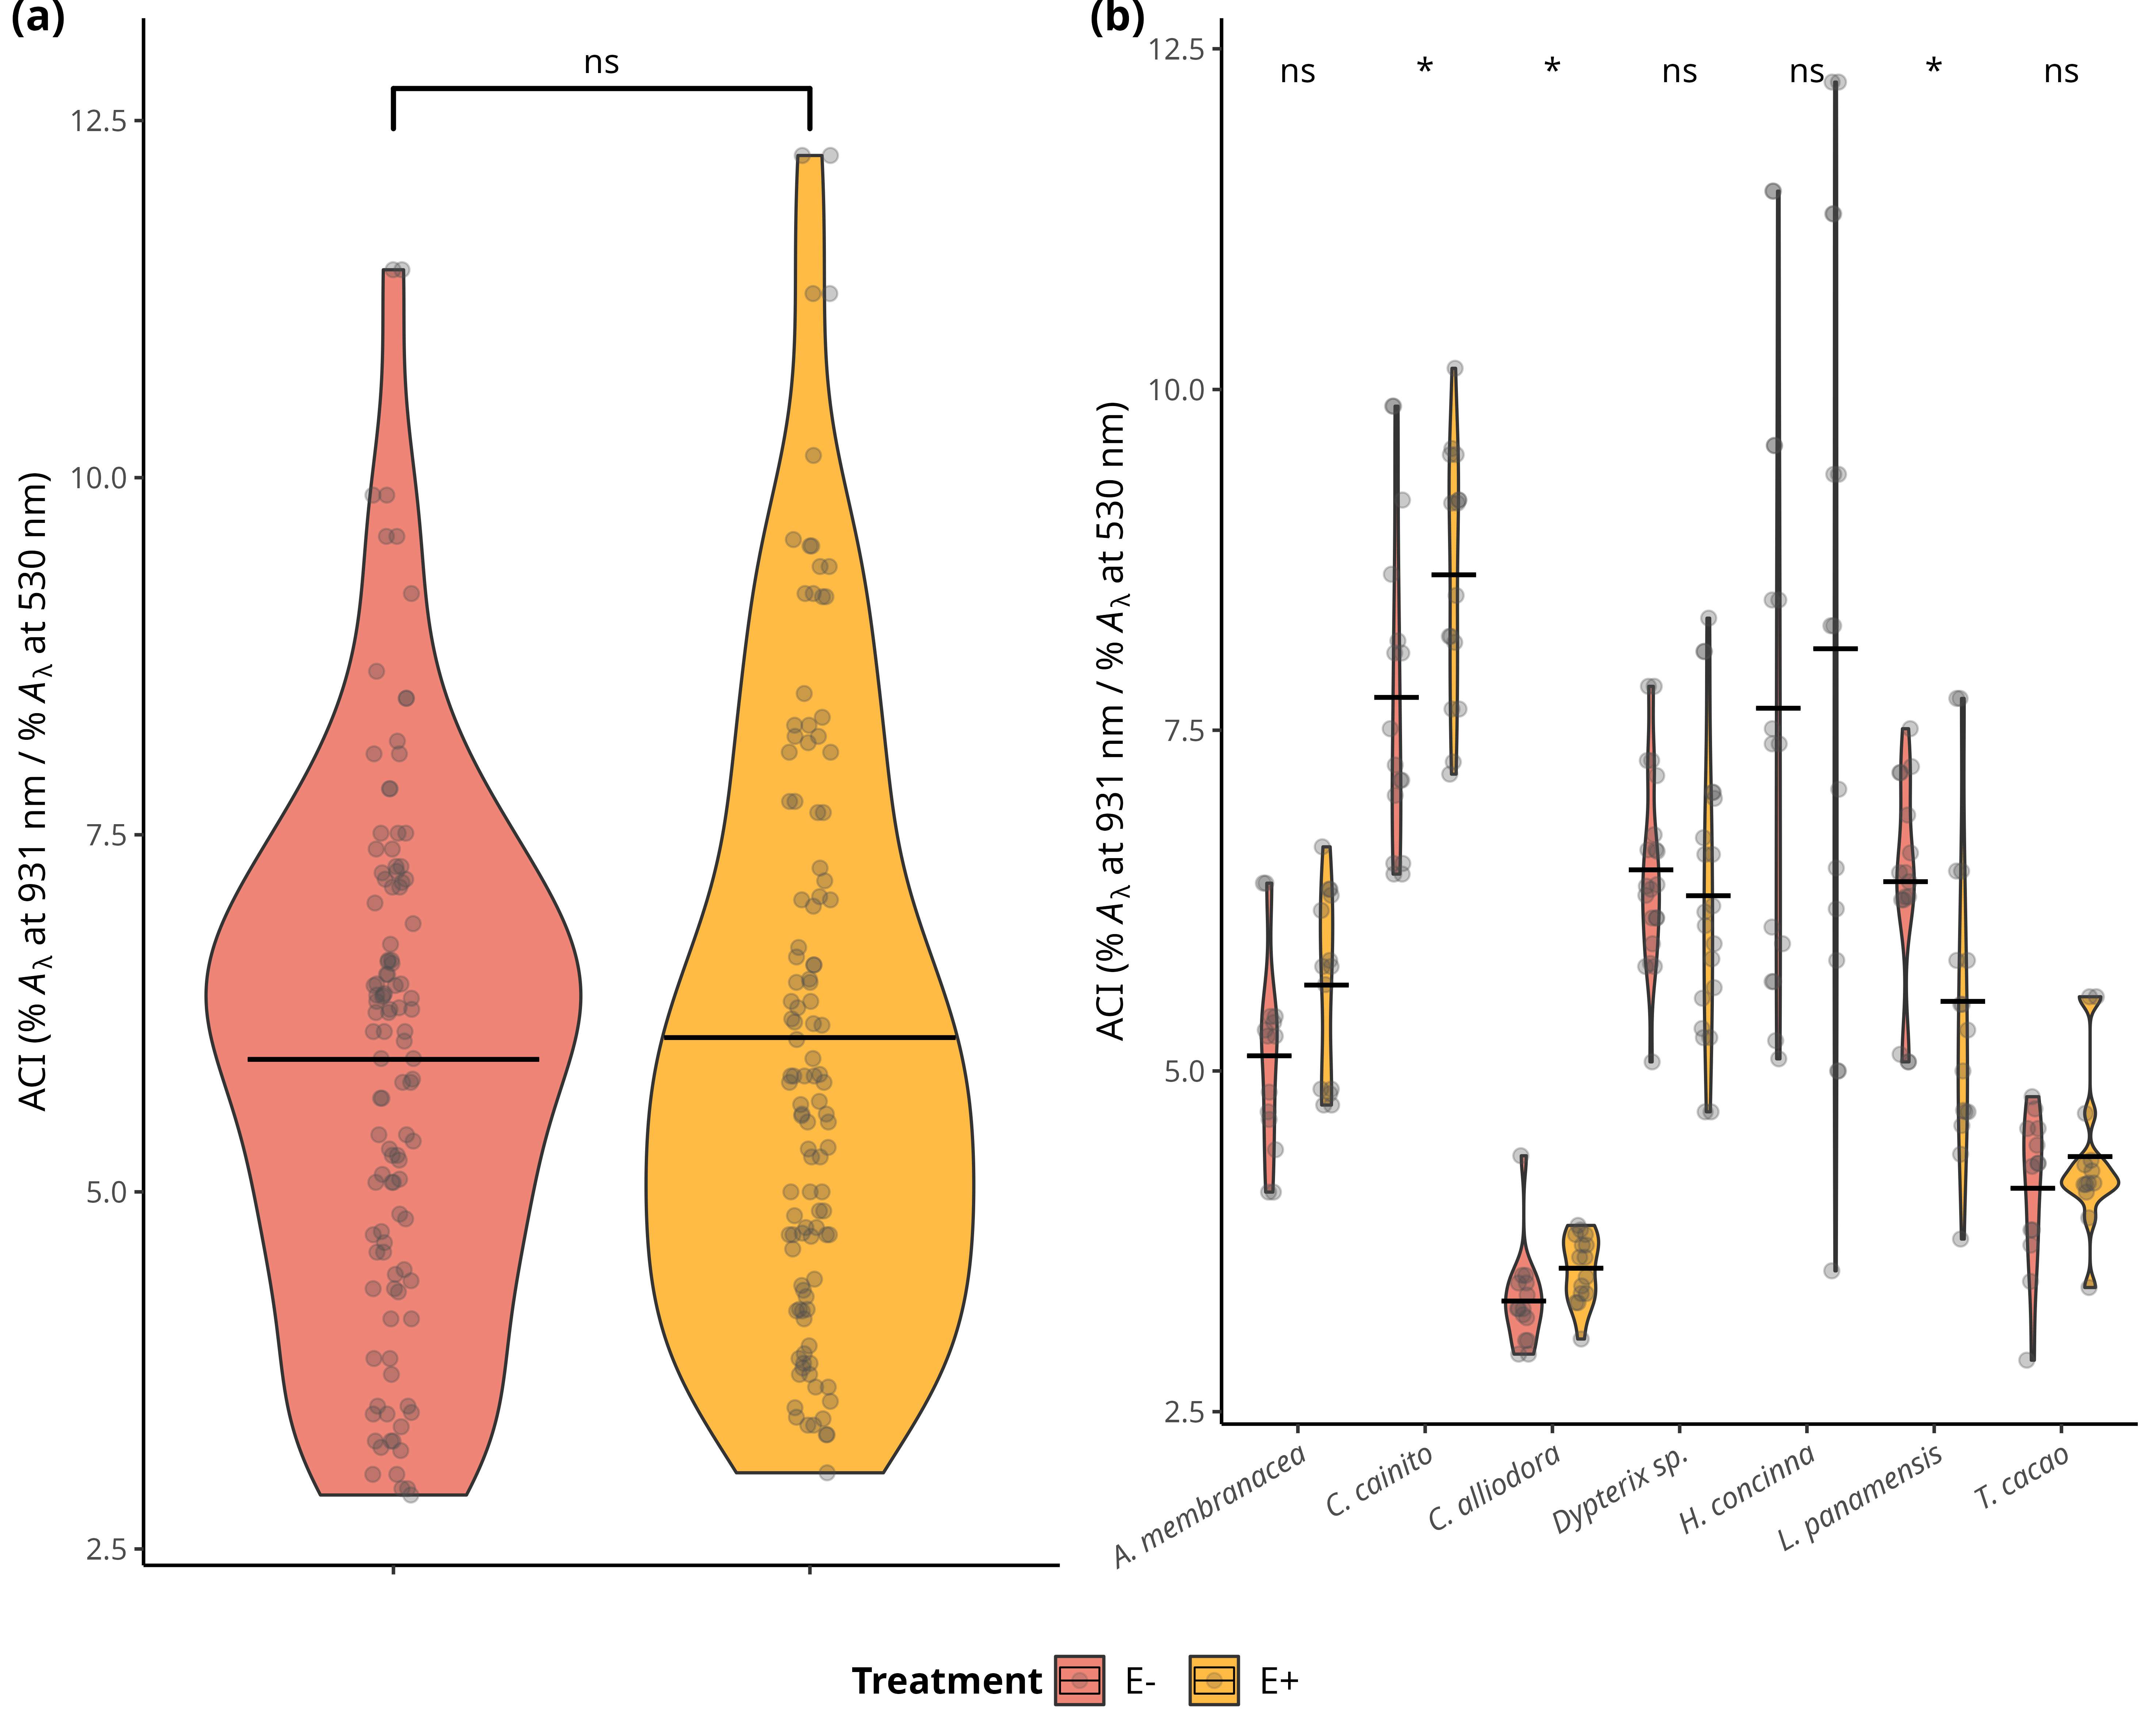

Distributions of values and means of anthocyanin content (ACI) in treatment groups (*E-* and *E+*) and tree species. a) Comparison of ACI means between treatment groups across individuals of all species. Statistical significance was calculated using a two-sided Student’s t-Test. b) Comparison of ACI means between treatment types of each species. Statistical significance was calculated with an analysis of variance (ANOVA). Pink filled violins represent low FEF group (*E-*) and yellow filed violins represent high FEF group (*E+*). SSignificance levels are represented by ns (not significant) and asterisks [p < 0.05 (*), p < 0.01 (**), p < 0.001 (***), and p < 0.0001 (****)].

## 15.12 Figure S3a-S3b

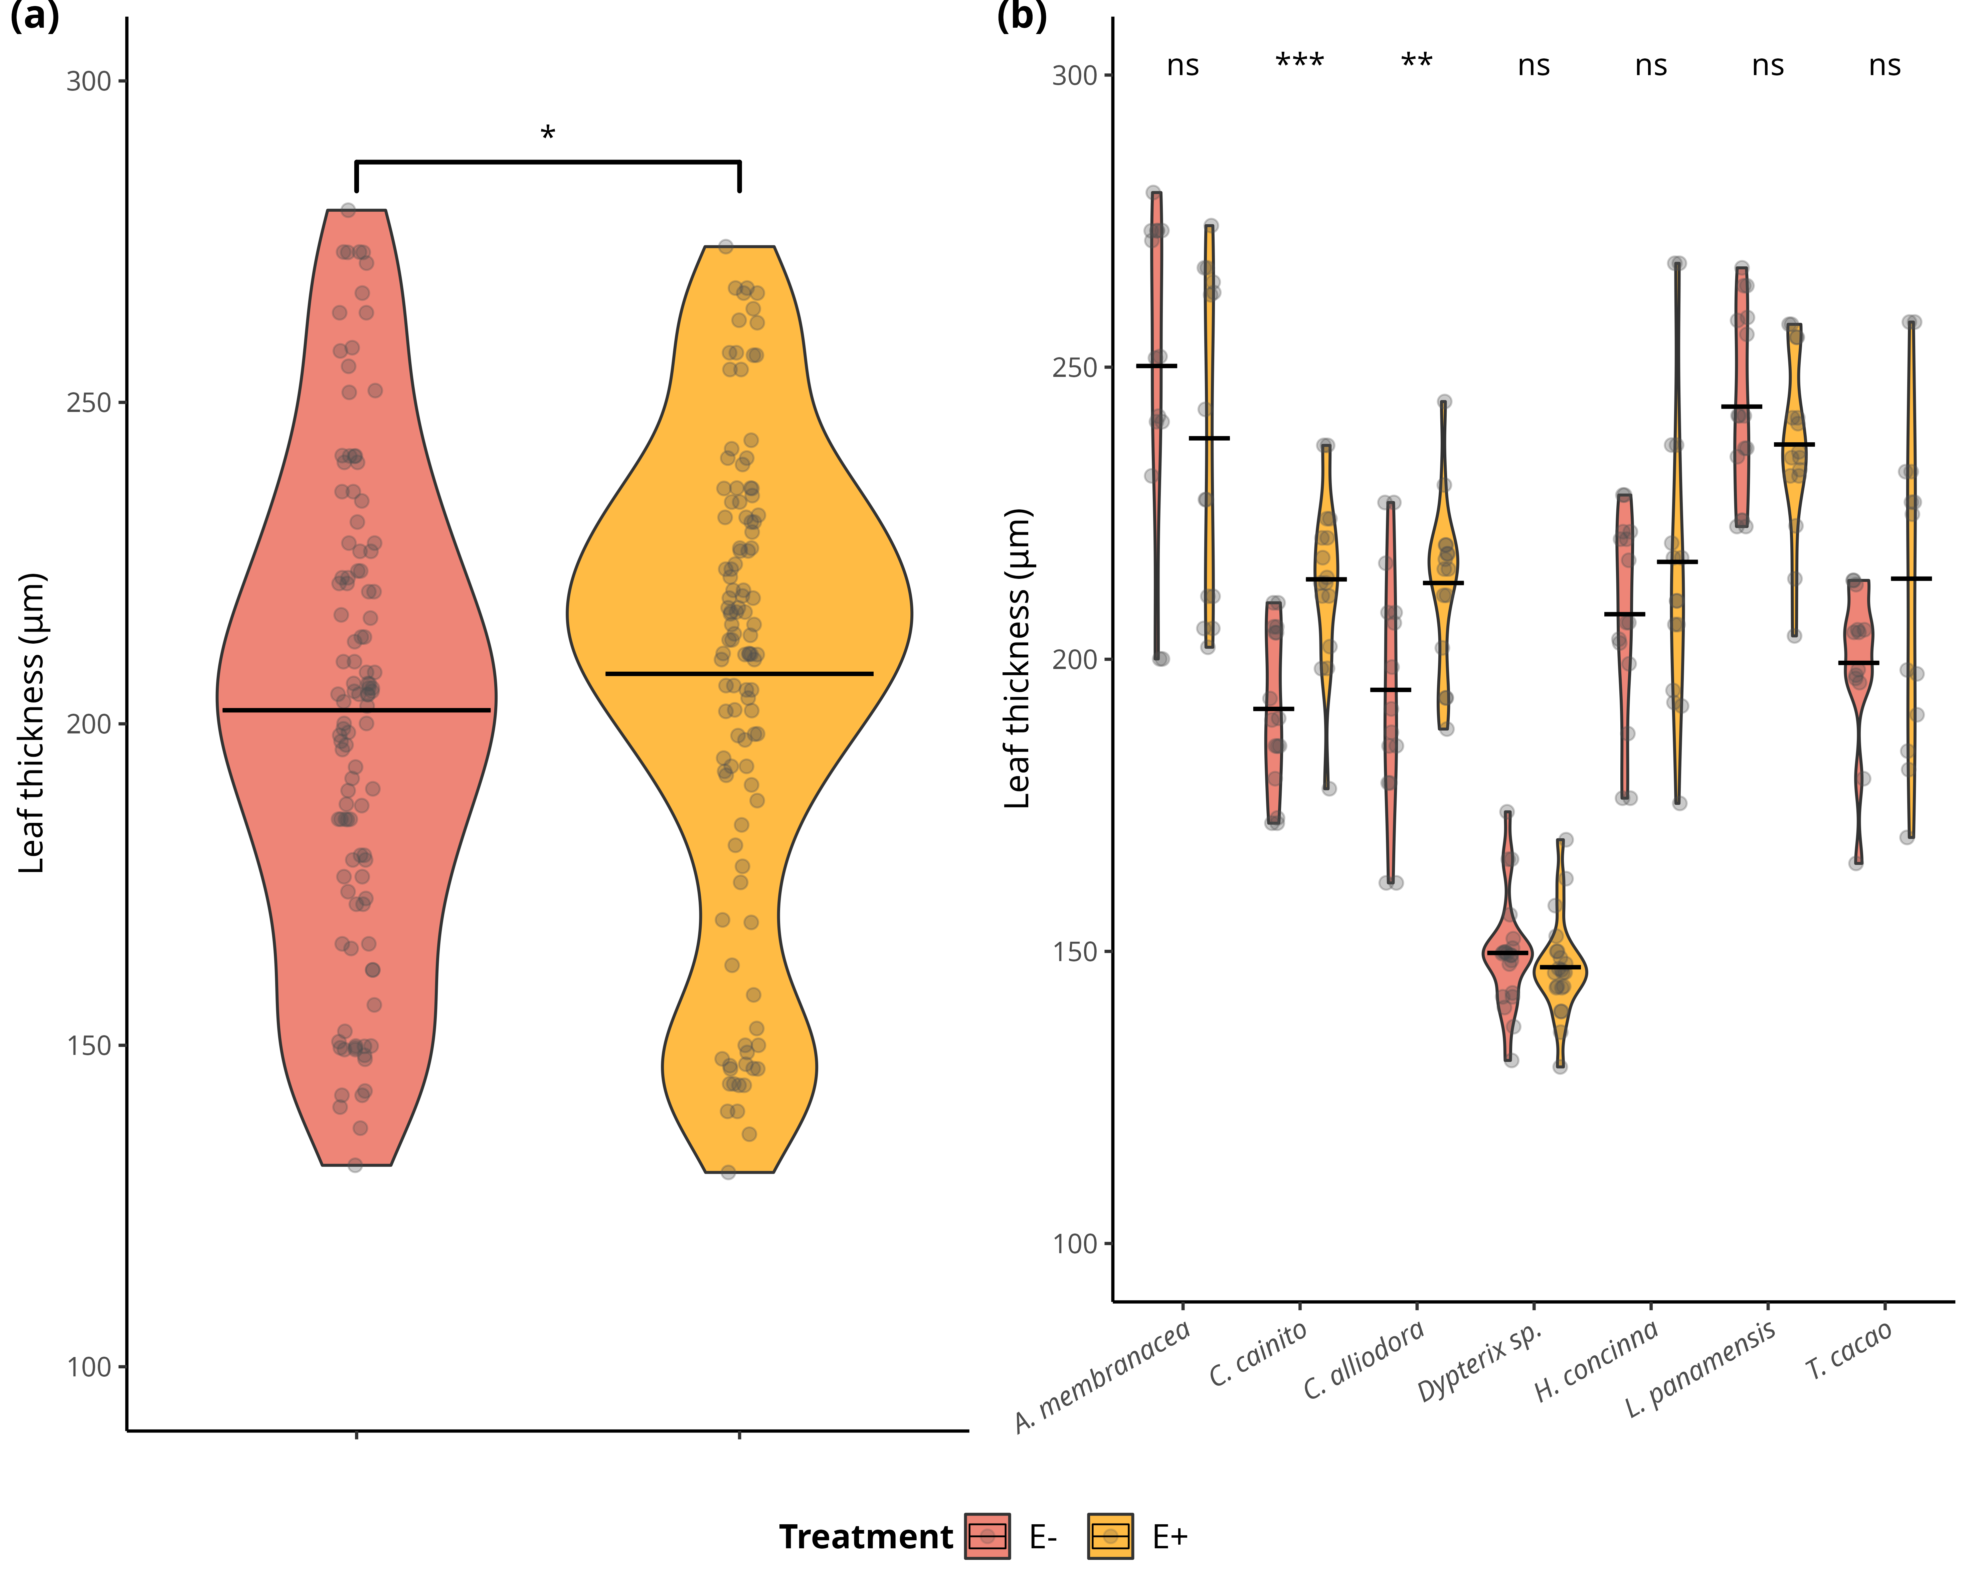

Distributions of values and means of leaf thickness (LT) (μg) in treatment groups (*E-* and *E+*) and tree species. a) Comparison of LT means between treatment groups across individuals of all species. Statistical significance was calculated using a two-sided Student’s t-Test. b) Comparison of LT means between treatment types of each species. Statistical significance was calculated with an analysis of variance (ANOVA). Pink filled violins represent low FEF group (*E-*) and yellow filed violins represent high FEF group (*E+*). Significance levels are represented by ns (not significant) and asterisks [p < 0.05 (*), p < 0.01 (**), p < 0.001 (***), and p < 0.0001 (****)].

## 15.13 Figure S4a-S4b

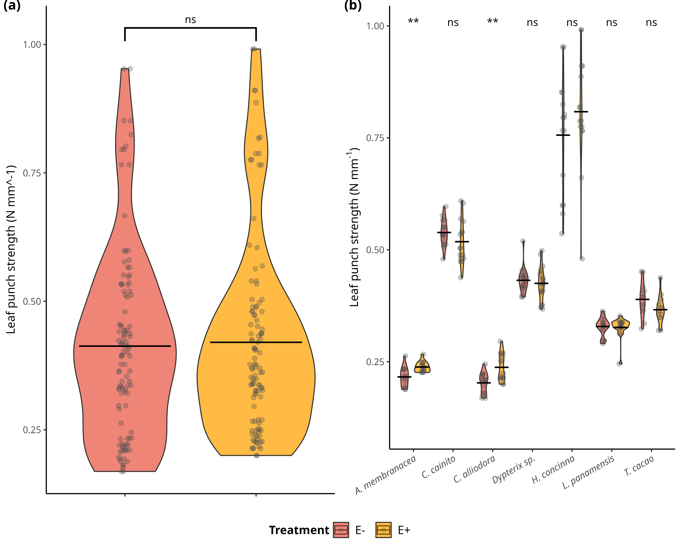

Distributions of values and means of leaf punch strength (LPS) (N mm^-1) in treatment groups (*E-* and *E+*) and tree species. a) Comparison of LPS means between treatment groups across individuals of all species. Statistical significance was calculated using a two-sided Student’s t-Test. b) Comparison of LPS means between treatment types of each species. Statistical significance was calculated with an analysis of variance (ANOVA). Pink filled violins represent low FEF group (*E-*) and yellow filed violins represent high FEF group (*E+*). Significance levels are represented by ns (not significant) and asterisks [p < 0.05 (*), p < 0.01 (**), p < 0.001 (***), and p < 0.0001 (****)].

## 15.14 Figure S5a-S5b

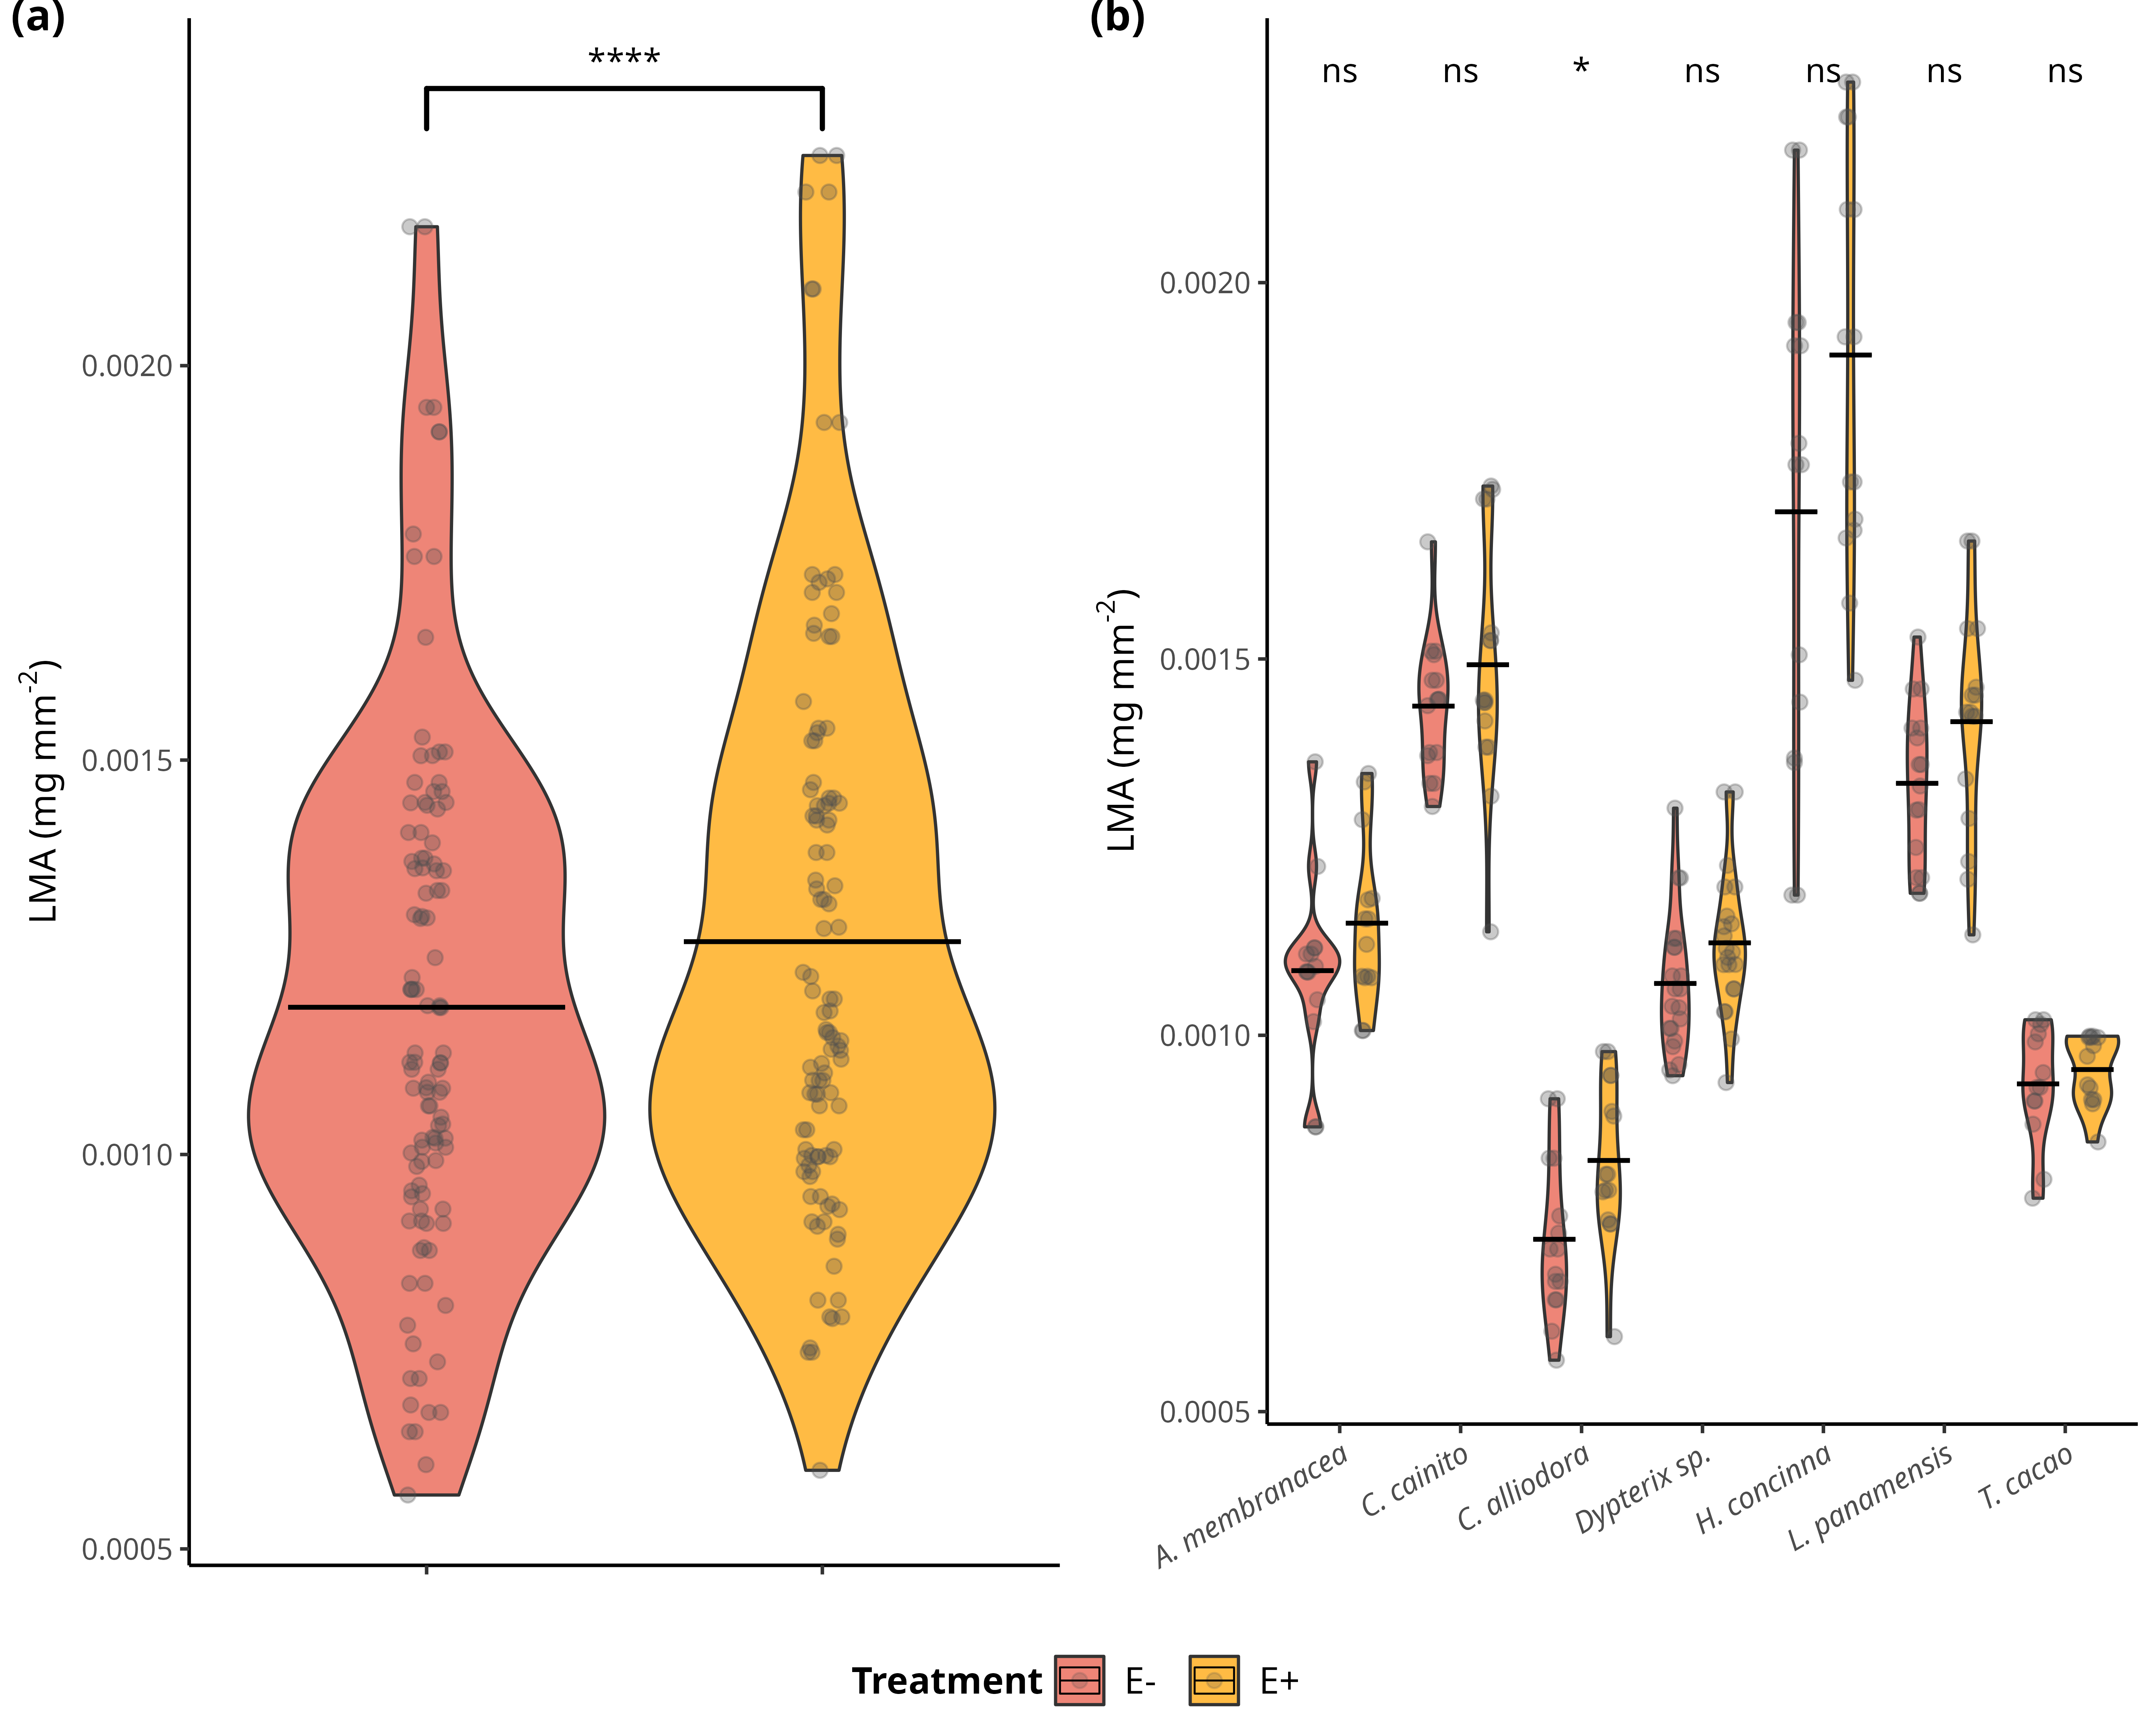

Distributions of values and means of leaf mass per area (LMA) (mg mm^2) in treatment groups (*E-* and *E+*) and tree species. a) Comparison of LMA means between treatment groups across individuals of all species. Statistical significance was calculated using a two-sided Student’s t-Test. b) Comparison of LMA means between treatment types of each species. Statistical significance was calculated with an analysis of variance (ANOVA). Pink filled violins represent low FEF group (*E-*) and yellow filed violins represent high FEF group (*E+*). Significance levels are represented by ns (not significant) and asterisks [p < 0.05 (*), p < 0.01 (**), p < 0.001 (***), and p < 0.0001 (****)].

## 15.15 Figure S6a-S6b

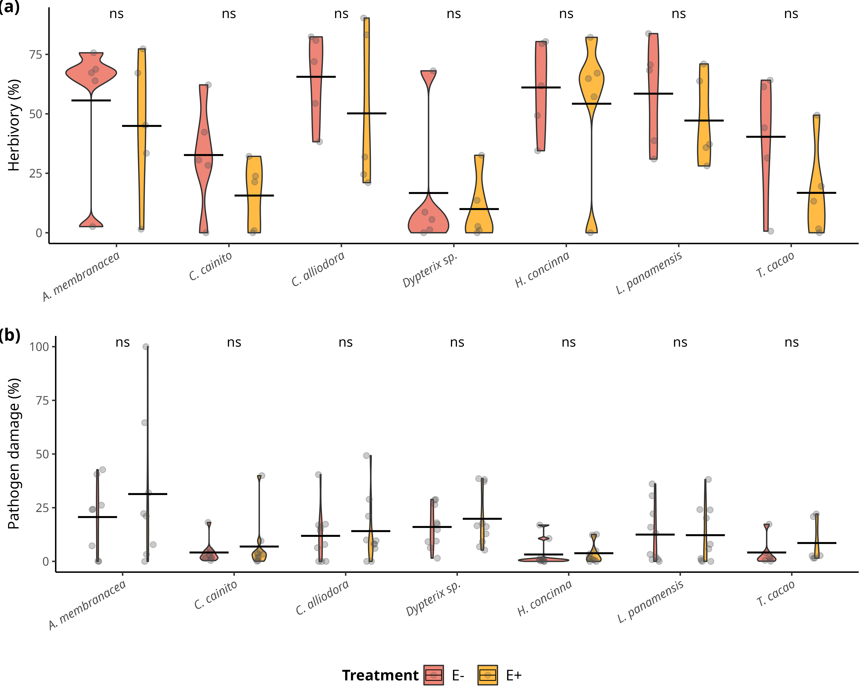

Distributions of values and means of herbivory (%) and pathogen damage caused by *Atta colombica* and *Calonectria* sp. , respectively, in treatment groups (*E-* and *E+*) per tree species. a) Comparison of herbivory (%) means between treatment groups across individuals of all species. b) Comparison of pathogen (%) means between treatment groups across individuals of all species. Pink filled violins represent low FEF group (*E-*) and yellow filed violins represent high FEF group (*E+*). Statistical significance was calculated with an analysis of variance (ANOVA). Significance levels are represented by ns (not significant) and asterisks [p < 0.05 (*), p < 0.01 (**), p < 0.001 (***), and p < 0.0001 (****)].

## 15.16 Figure S7

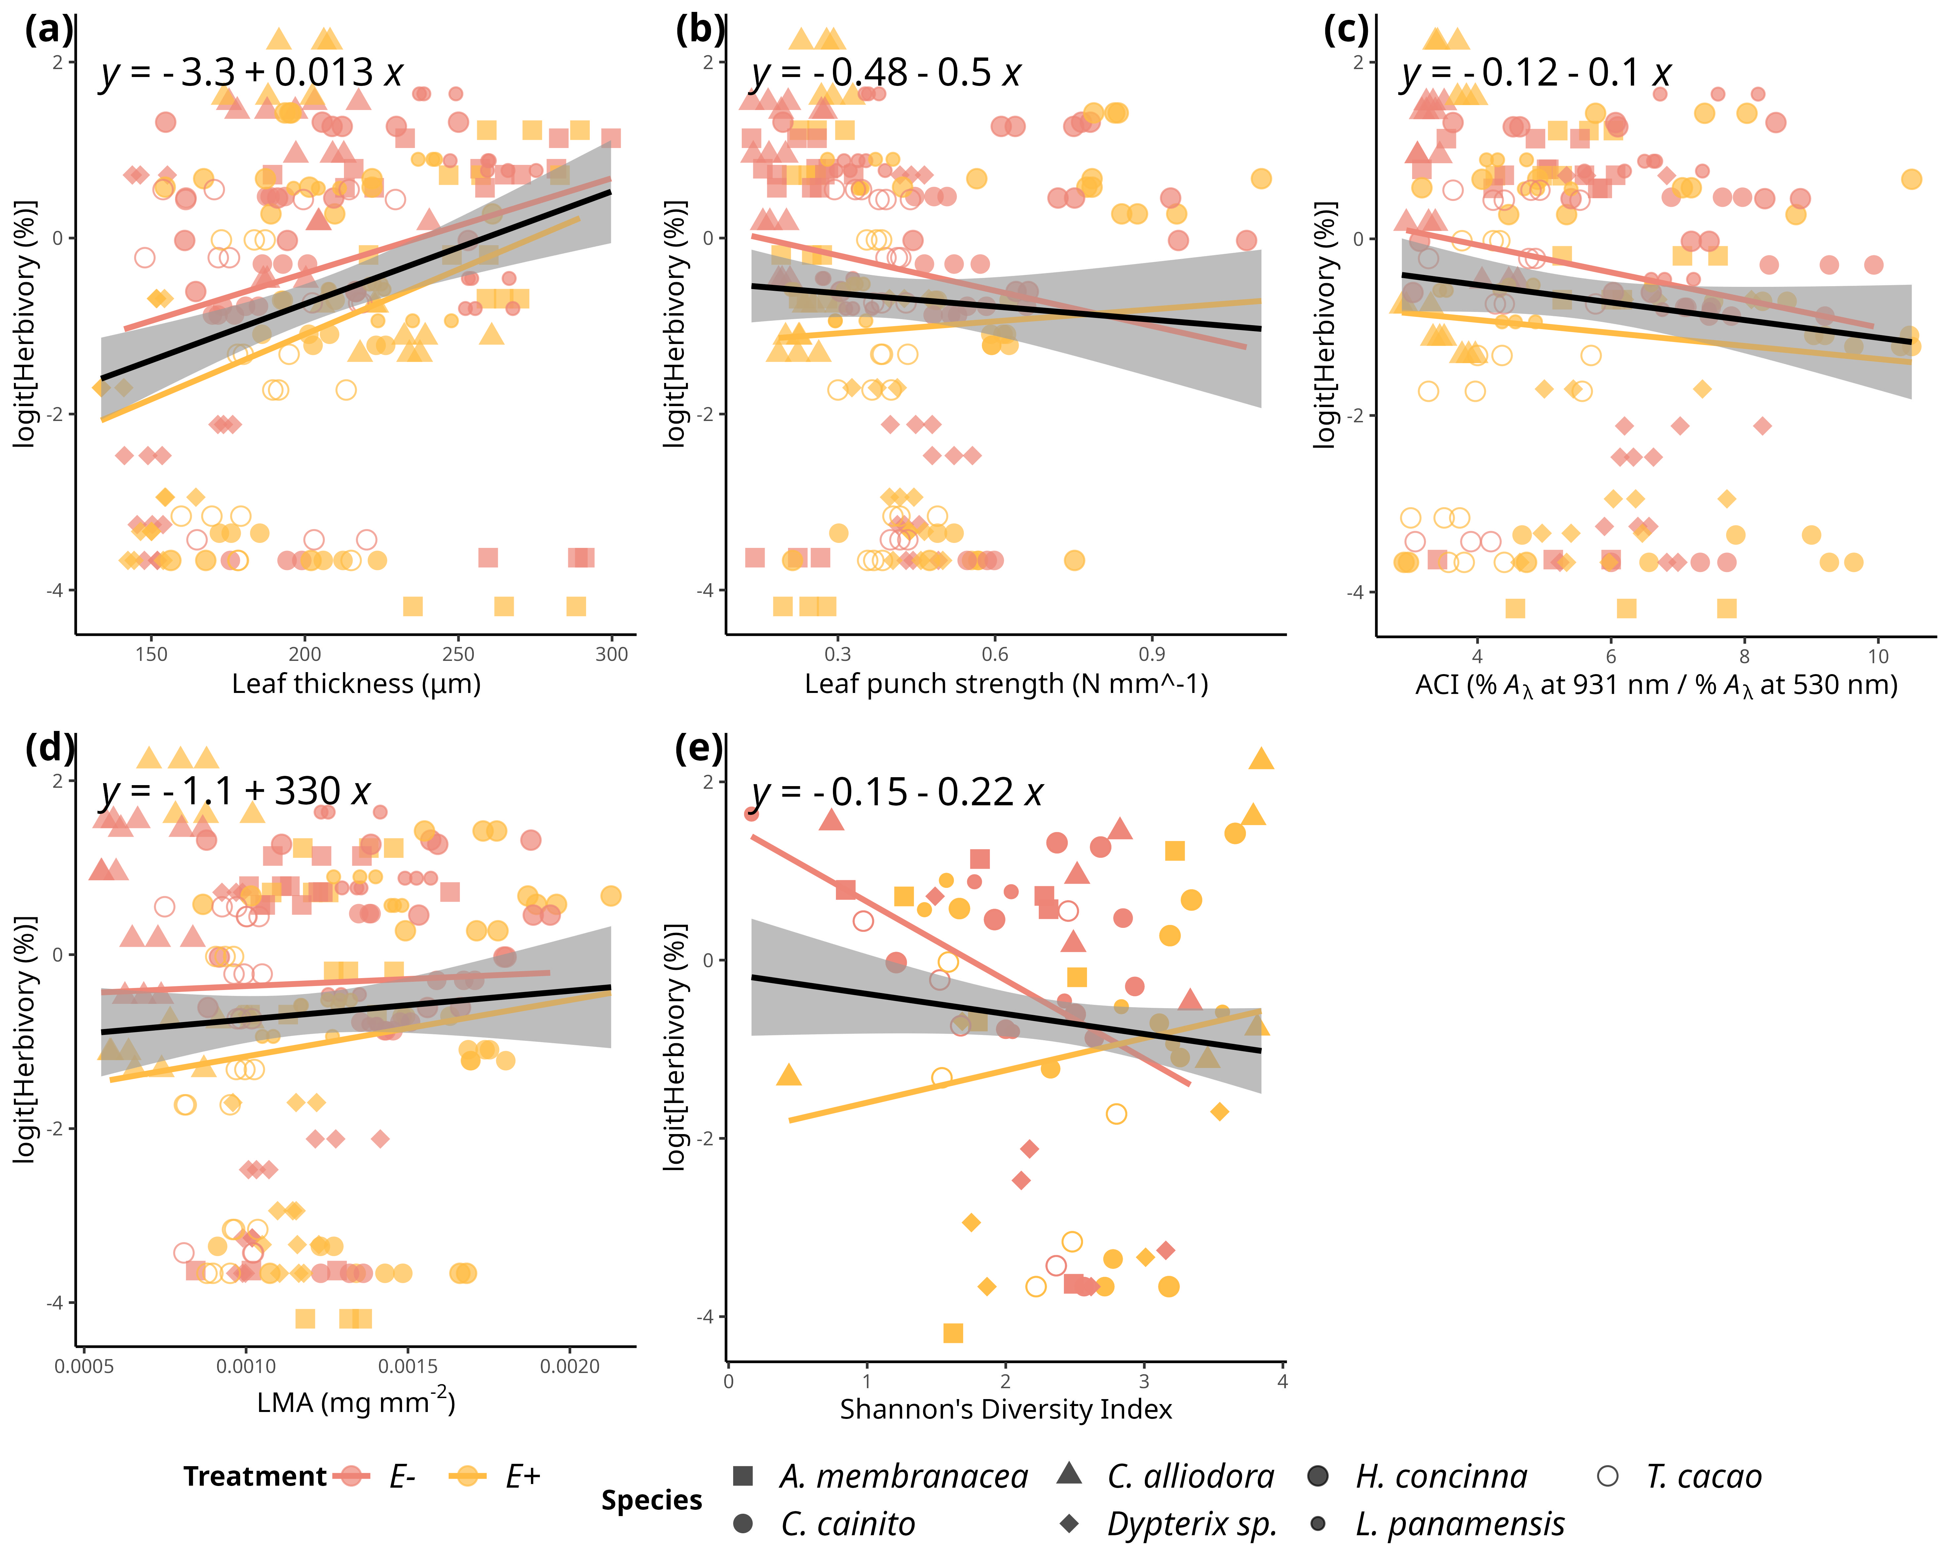

Simple linear regressions of logit transfomed herbivory (%) and and leaf functional traits. a) Herbivory *vs.* leaf thickness (LT) (μg) (R2-adjusted= 0.0811, *p* < 0.0001). b) Herbivory *vs.* LPS (N mm-1) (R2-adjusted= -0.0018, *p* = 0.429)). c) Herbivory *vs.* ACI (R2-adjusted= 0.0071, *p* = 0.116). d) Pathogen *vs.* LMA (mg mm^2) (R2-adjusted= -0.0008, *p* = 0.36). e) Herbivory *vs.* Shannon diversity index (R2-adjusted= 0.007 , *p* = 0.12). Pink filled line and shapes represent low FEF group (*E-*) and yellow filled line and shapes represent high FEF group (*E+*). Black line represents the linear regression on all observations. Significance levels are represented by ns (not significant) and asterisks [p < 0.05 (*), p < 0.01 (**), p < 0.001 (***), and p < 0.0001 (****)].

## 15.17 Figure S8

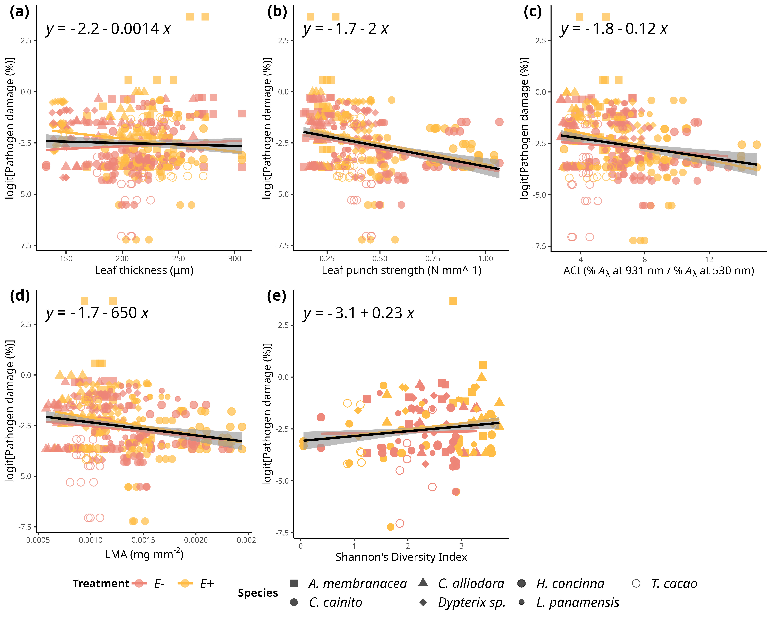

Simple linear regressions of logit transformed pathogen damage (%) and and leaf functional traits. a) Pathogen damage *vs.* leaf thickness (LT) (μg) (R2-adjusted= -0.0013, *p* = 0.482). b) Pathogen damage *vs.* LPS (N mm-1) (R2-adjusted= 0.0782, *p* < 0.0001)). c) Pathogen damage *vs.* ACI (R2-adjusted= 0.0338, *p* < 0.001). d) Pathogen *vs.* LMA (mg mm^2) (R2-adjusted= 0.0295, *p* < 0.001). e) Pathogen damage *vs.* Shannon diversity index (R2-adjusted= 0.0152 , *p* < 0.001). Pink filled line and shapes represent low FEF group (*E-*) and yellow filled line and shapes represent high FEF group (*E+*). Black line represents the linear regression on all observations. Significance levels are represented by ns (not significant) and asterisks [p < 0.05 (*), p < 0.01 (**), p < 0.001 (***), and p < 0.0001 (****)].

## 15.18 Figure S9

*Simple linear regression on even and tiered mock FEF communities.*